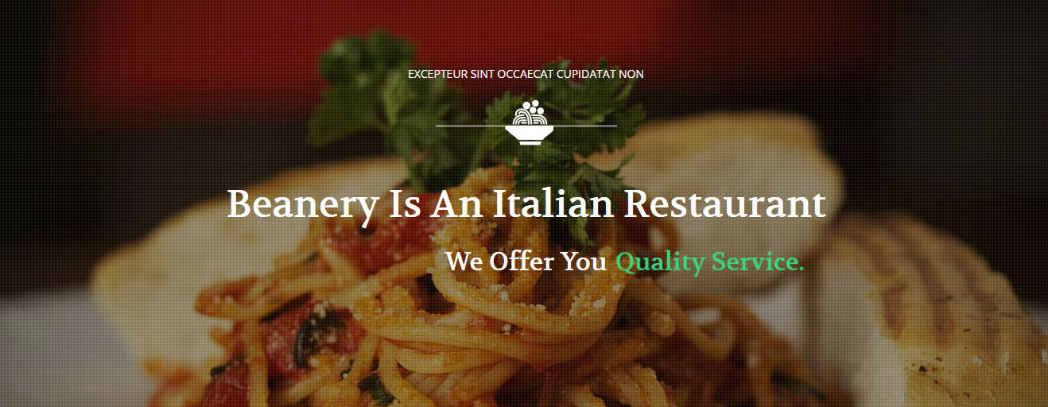

Beanery is a Italian Restaurant that offers food of all quality and doing a great work by delivering a good Italian food to people. Emperors came and went.  
Men and women loved and died  
But the food…

Its traditions and recipes stand the test of time.  
Its embrace reaching the cradle of early man.  
Passed on from mouth to ear and reborn again

The birth of this restaurant is all of me.  
The dark corners that are also held tightly by the bond of laughter  
Long Dinners, Great Food  
And the deep unshakable knowing of belonging

**Admin Zone**

By logging in into the admin zone admin can do the following works

* Can view the contact messages
* Can add, update, Delete new staff
* Can see the Salary records
* **Admin login details**

**USERNAME:** [**admin@gmail.com**](mailto:admin@gmail.com)

**PASSWORD: admin**

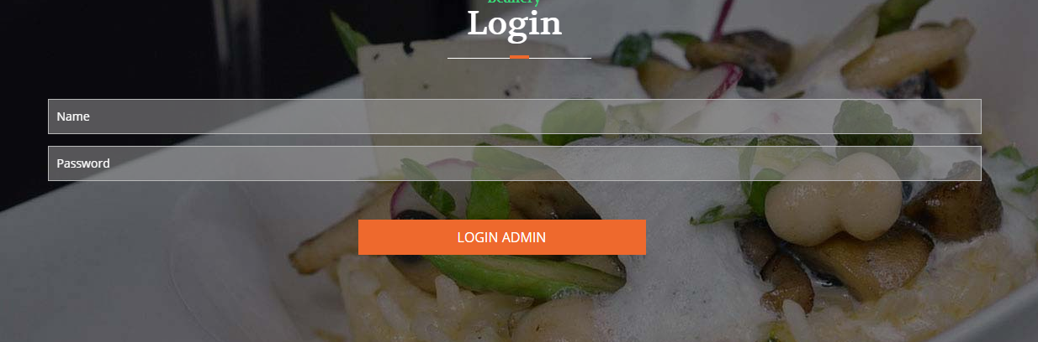

**Home Page:**

 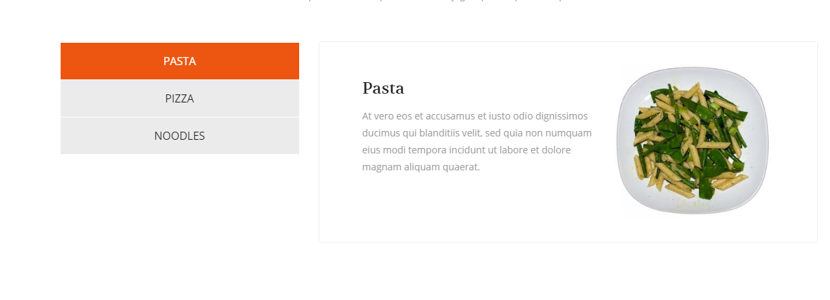

**About :**

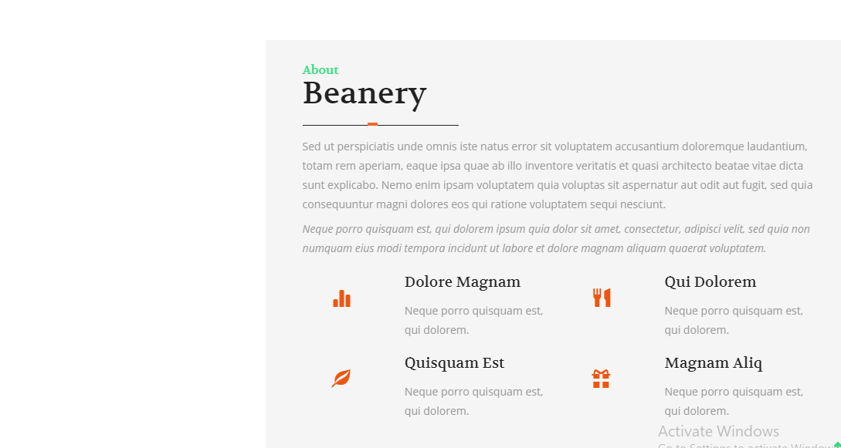

Gallery :

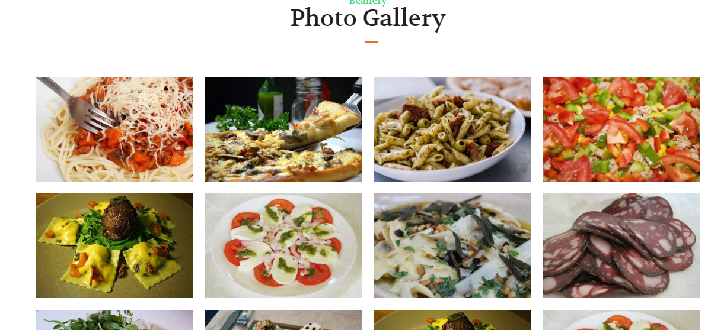 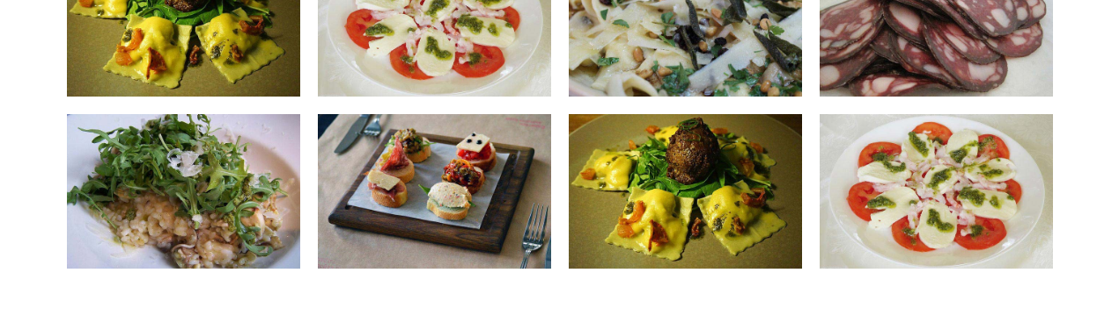

Contact Us :

